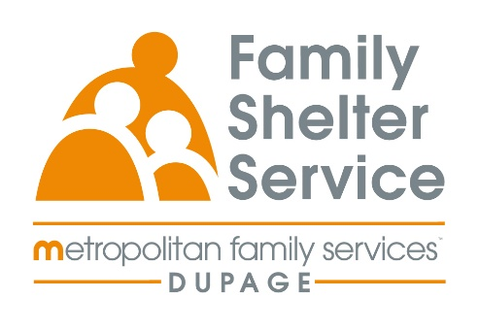
40hr Domestic Violence Training
January 14-16 and 21-24, 2025
Time: Tues-Thurs
20/20: ICADV Modules & In-Person

Training Schedule:

Tuesday, January 14th 5:30-8:30pm Effects of DV on Children

Wednesday, January 15th 5:30-8:30pm TDV & Post Separation Abuse

Thursday, January 16th 5:30-8:30pm Cultural Humility

Tuesday, January 21st 5:30-8:30pm Services for Survivors Part 1

Wednesday, January 22nd 5:30-8:30pm Services for Survivors Part 2 &
People Who Cause Harm in Relationships

Thursday, January 23rd 5:30-8:30pm Safety & Assessment

Tuesday, January 24th 5:30-8:30pm Professional Conduct

Registration link: https://www.eventbrite.com/e/2020-dv-training-january-2025-tickets-1069606534939

Registration open: Friday, November 1st at 9am
Registration ends: Friday, January 3rd at 12pm

